CS3205: INTRODUCTION TO COMPUTER NETWORKS
ASSIGNMENT 4

ARJUN BHARAT,CS17B006

INTRODUCTION

The aim of the assignment was to obtain the canonical names of websites by using nslookup. A study of mail servers associated with specific websites was also done.

1. IP AND MAC ADDRESS OF THE SYSTEM:

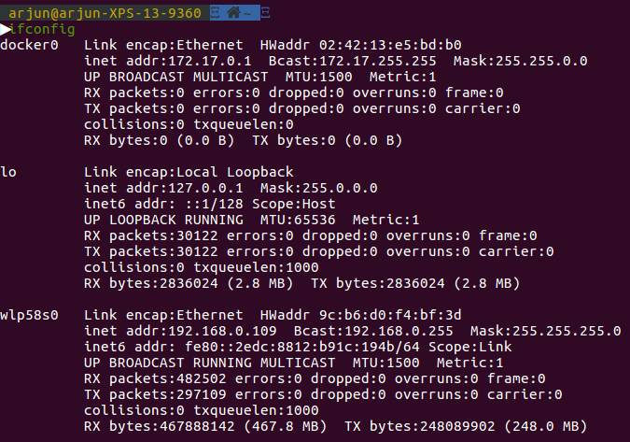

A WiFi network was used, and hence the IP address is given by the wlp58s0 filter.

2. DOMAINS USED FOR THIS ASSIGNMENT:

The following webistes were used for the assignment:
- www.indiaeducation.net
- www.tu-darmstadt.de
- www.umich.edu
- www.goidirectory.nic.in
- www.ifsr.in
- www.myntra.com
- www.inferno.fitness
- www.just.jobs
- www.nzherald.co.nz
- www.snet.lu

3. RESULTS OF THE TESTS PERFORMED

The results of the tests are summarised , website by website as follows:

a) For www.indiaeducation.net

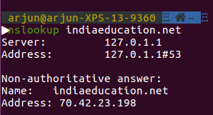

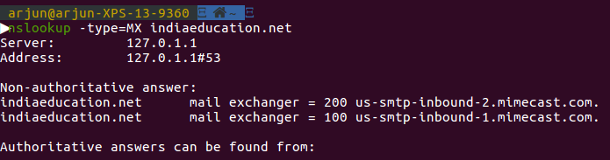

Observations:

There are 2 primary mail exchange servers used. Both are likely mirror webistes to reduce the load. This webiste has no canonical name.

b) For www.tu-darmstadt.de

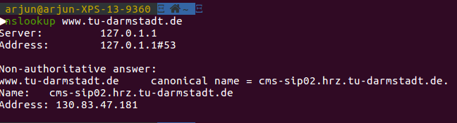

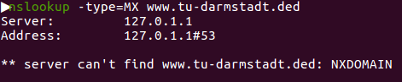

Observation:
The website has a canonical name as depicted. However, no mail server exists for this educational website.

c) For www.umich.edu

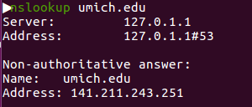

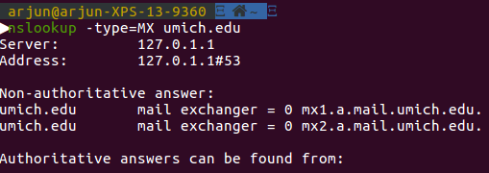

Observations:
There are 2 mail servers for this educational webiste in North America. However, no canonical aliases exist.

d) For www.goidirectory.nic.in
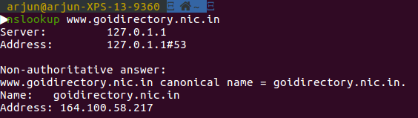

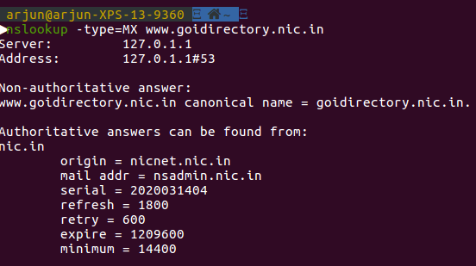

Observations:
The canonical name of the webiste is the same as its original name. An authorative answer was not obtained for this website.

e) For www.ifsr.in

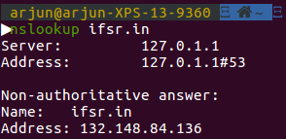

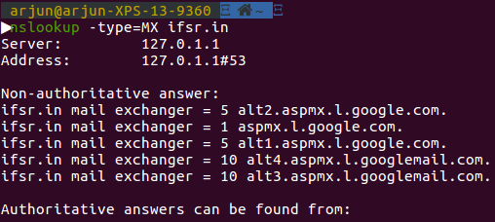

Observations:
There are no canonical names and 5 available mail servers.

f) For www.myntra.com

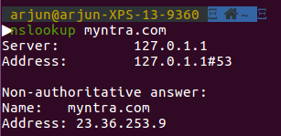

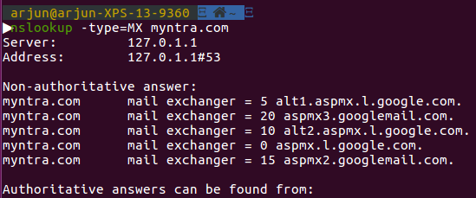

Observations:
This shopping website has 5 mail servers possibly due to heavy concurrent load.

g) For www.inferno.fitness

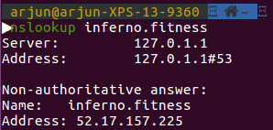

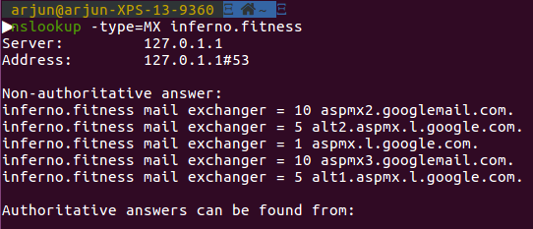

Observations:
This GLTD website has 5 mail servers as shown. They are all hosted by Google.

h) For www.just.jobs
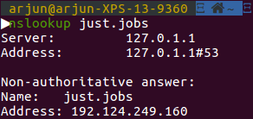

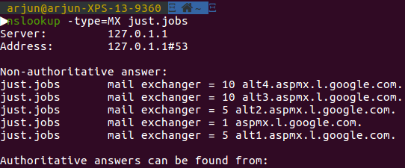

Observations:
This sponsored top level domain has 5 mail servers. All are hosted by Google.

i) For www.nzherald.co.nz

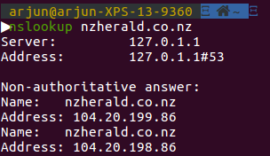

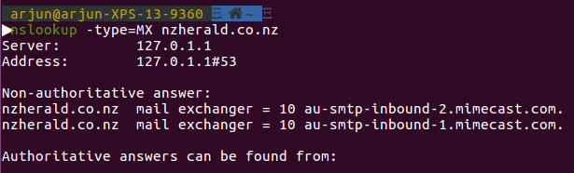

Observations:
This country level domain has 2 mail servers. Interestingly, www.indiaeducation.net also hosts its mail servers on the same website.

j) For www.snet.lu
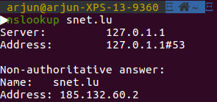

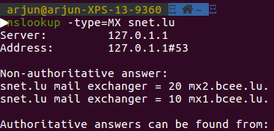

Observations:
This country level domain has 2 mail servers that are both hosted in Luxembourg.

4. EXPLAINING A FEW TERMS:

We touch upon the basic definitions of some terms:

- Serial: The zone serial number that is incremented when the zone file is modified. Thus, the slave and secondary name servers know when the zone has been changed.
- Refresh: The number of seconds between update requests from secondary and slave name servers.
- Retry: The number of seconds the slave or secondary server will wait before retrying.
- Expire: The number of seconds a master or slave waits before considering the data stale if it cannot reach the primary server. This is analagous to a timeout.
- Minimum: This is the default TTL value specified.
- TTL(Time To Live): The number of seconds a domain name is cached locally before expiration and returned to authoritative name servers for updated information.

5. CONCLUSION:

From this assignment, I learnt how to analyse and understand the working of nslookup to deduce mail servers associated with a website. By filtering DNS packets from the captured packets, we get an idea of the packets transferred from our system to the domain host that sends response packets.

